

----------------------------------------------------------------------------------------------------------------

**FIN42020 Derivative Securities**

**GROUP PROJECT**

------------------------------------------------------------------------------------

**Options Pricing and Delta Hedging**

------------------------------------------------------------------------------------------------

Presented by:

* Kuntoji, Rohan - 22202093 (MSc. Financial Data Science)
* Nagar, Shraddha - 22200477 (MSc. Financial Data Science)
* Fernandes, William - 22201553 (MSc. Financial Data Science)
* Pant, Vidushi - 22200808 (MSc. Financial Data Science)
* Parary, Aman - 18417714 (MSc. Financial Data Science)

**Option Pricing and Delta Hedging**

The provided data was used to achieve the following objectives outlined below.

**Objective 1**- **Selection of inputs for Black-Scholes Option Pricing, pricing of ATM option and implied volatility calculation**

We were assigned the ***18th of March, 2004,*** as our trade date on the basis of which the option pricing inputs were chosen. Details are mentioned below:

**a)** A 34 day zero rate (risk-free rate ‘r’) of ***1.10%*** was chosen from the zero data provided and it was the closest to our option expiration period of 30 calendar days (21 trading days) and hence the most appropriate in our case.

**b)** Dividend yield (*q*) – The divided yield was selected from the S&P dividend data provided. The yield corresponding to the assigned trade data was ***1.63%***

**c)** The Black-Scholes model was used for pricing the call and put option. Black-Scholes model was originally developed to price options on non-dividend paying stock. However, the model has been adapted to price option on stocks that pay dividend and other complex options. For pricing options, the model requires five inputs namely, the time to expiration, option’s strike price, risk-free rate, current underlying spot price and its volatility. The model assumes stock prices follow a lognormal distribution because asset prices cannot be negative.

Call (C) and Put (P) option price formulae are as follows:





where d1 and d2 formulae are as follows:

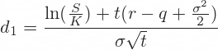



where,

C = Call option price

P = Put option price

S = Current underlying price (spot price)

K = Strike price

r = Risk free interest rate

q = Dividend yield

t = Time to maturity

N = Normal Distribution

The underlying SPX index spot price (S) corresponding to our trade date was ***$1122.32,*** which was the adjusted closing price from the S&P 500 index on the date.

At the money (ATM) strike price (K) ***$1120.00*** was used from the option pricing metrics that was provided.

The time to maturity (t) - ***21 trading days*** *(30 calendar days)*

Implied volatility value (sigma) from the provided option metrics was used to price the options using Black-Scholes model on our trade date of 18/03/2004.

Generally for an ATM option, an increase in the underlying security price would have a significant impact on the fair value of the option. This will drive the price higher for call options and vice versa in the case of put options. Since a risk-free rate reflects the time value of the exercise price, a higher risk-free rate increases the fair value of the call option. However, as the risk-free rate increases, the value of a put option decreases.

**Outcomes of option pricing exercise using the Black-Scholes model (B-S-M):**

Using the inputs mentioned above, the price of the option was determined using the Black-Scholes model with dividend yield. The price obtained for At The Money (ATM) call option was ***$22.92***. The obtained ATM call price was then compared with the mid-point of its bid-ask spread of ***$22.05*** and we found that both the values were relatively close to each other.

Similar exercise was conducted for pricing an ATM put option. The price obtained for ATM put option was ***$19.78***. The mid-point of the bid-ask spread was calculated to be ***$16.55***. We observed a slightly higher difference in the two prices, which could be attributed to limitations of the B-S-M model since it only attempts to provide the fair value of the options under certain assumptions and these assumptions do not always hold true. The volume or demand and supply for option contracts can affect the actual bid-ask spread.

**d)** Determining the implied volatility:

Implied volatility is calculated by equating the B-S-M option price equation to the mid-point of its bid-ask spread and then solving the equations to derive the volatility value. Using the Newton Raphson Method, one of the fastest root-finding approximation methods, we compute the implied volatility for which the BSM prices match exactly with the mid-points of both the ATM call & put bid-ask spreads.

Newton Raphson Method is given by the equation,



Where, *f(xn)* is a function that is the theoretical (B-S-M) option price – the actual option price and  *f′(xn)* is the Vega, or the option price sensitivity to implied volatility

*f′(xn)=SN′(d1)√T*

The implied volatility calculated for the ATM call option from the above method was ***16.40%***. The same method was used to calculate the implied volatility of the ATM put option, which gave a value of ***13.60%***.

**e)** Comparison of implied volatility from B-S-M and actual volatility:

|  |  |  |  |
| --- | --- | --- | --- |
|  | **Implied Volatility** | | |
|  | **Actual** | **Estimated** | **Difference** |
| **Call Option** | 17.05% | 16.40% | 65 bps |
| **Put Option** | 16.02% | 13.60% | 242 bps |

The difference of ***65bps*** was observed between the implied and actual volatility for the ATM call option. Similarly, a relatively higher difference of ***242bps*** was observed for the ATM put option. The difference can be attributed to liquidity as mentioned earlier. This difference in volatility could have influenced the previously estimated put option price obtained from B-S-M and option metrics too.

**Objective 2- Use at the money option and the data obtained in question 1 (interest rate, dividend yield, implied volatility, along with the option strike and time to expiry) when we hold the other variables constant to produce the following graphs to show:**

**a)** Sensitivity of Option price to changes in volatility (Greek – Vega):

To check the sensitivity of option price to changes in volatility, the option was priced using a range of volatility (σ) values in steps of 5% (from σ = 5% to σ = 80%). The below plot was obtained from the analysis of both call & put options.

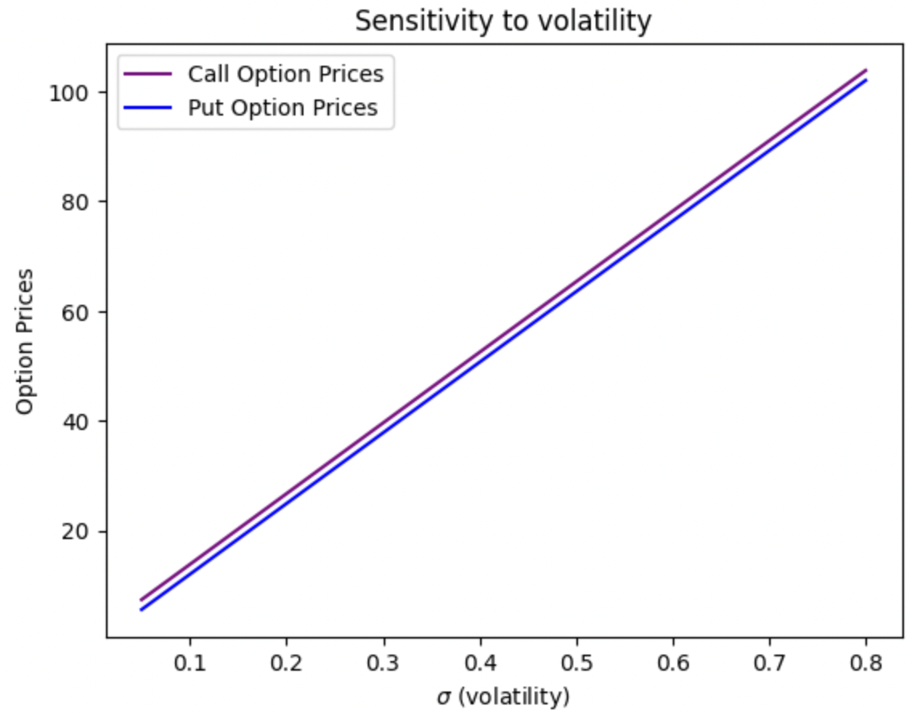

*Fig 2.1 The plot above indicates a positive relation for both Put and Call prices w.r.t volatility*

As volatility of the underlying security increases, both call & put options tend to rise because, higher volatility increases liquidity and possibility of options finishing in-the-money, thus making them more valuable.

**b)** Using the first two derivatives w.r.t. delta and gamma in a Taylor series expansion, a superimposed plot of the projected price around the calculated option price using the same volatility grid of price changes in the range -30% to +30%:

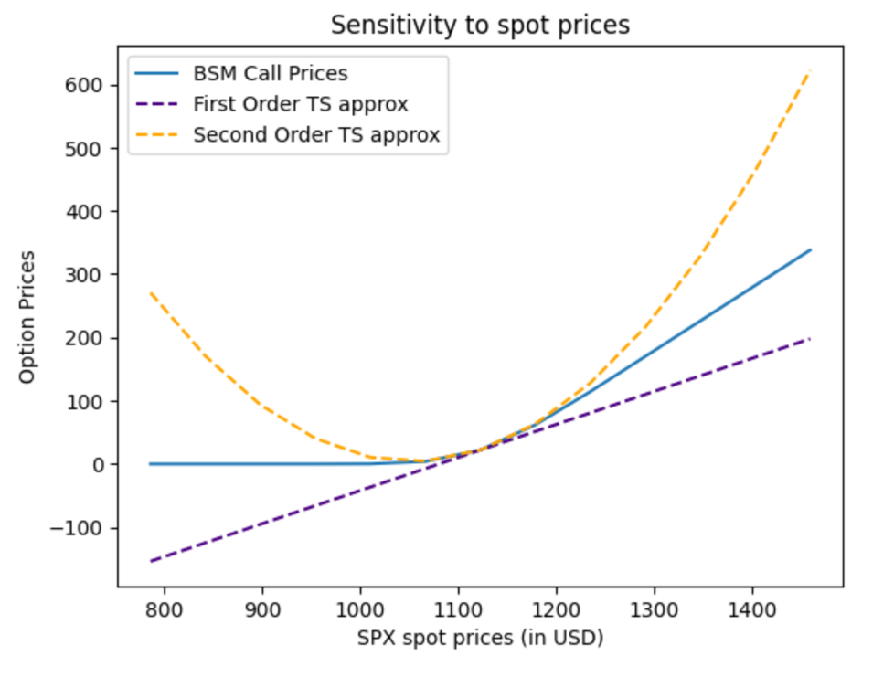

*Fig 2.2 The graph shows the change in option prices for a given change in SPX spot prices. We can infer that the gap between BSM price and TS approximation is lower at the strike and the gap widens as we approximate away from the strike*.

The above plot shows that the option prices obtained from B-S-M and the Taylor series. As per the plot, the values were close at strike price when the option is at the money. When option is out of the money or in the money, the change in stock does not result in equal change in call price considering the price interval of -30% to +30%, hence there is gap between B-S-M price and the price derived from Taylor series as noted in the above plot. We can also observe that the second order TS approximations are closer to the actual B-S-M prices in comparison with the first order TS approximations, and the gap reduces further for higher order TS approximations.

**c)** Sensitivity of B-S-M option price to changes in the time to maturity:

The sensitivity of the option price to time to expiry (also called time to maturity) was determined by varying the horizon from one week to five years. The periods used for the analysis were T= 1 week, 1 month, 1 quarter, 6 months, 1 year, 5 years (all in trading day terms – though the ratio remains the same).

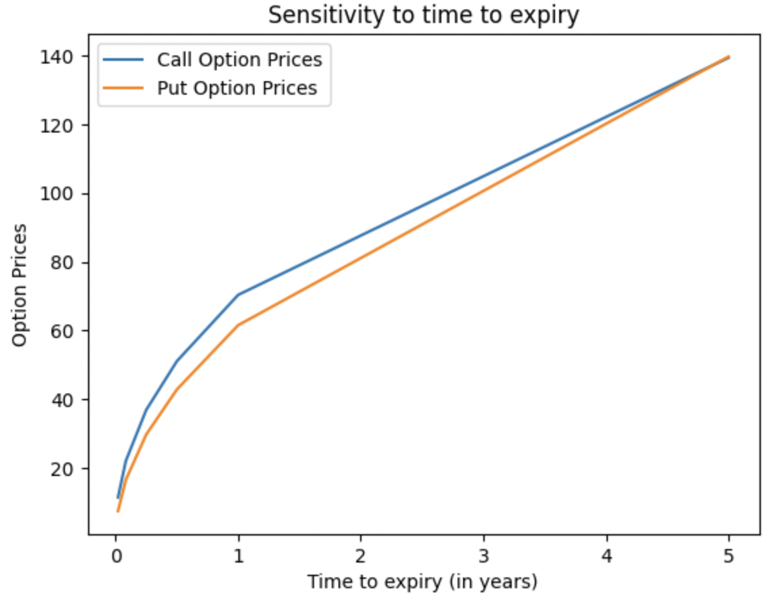

*Fig 2.3 The graph shows the change in option prices to differing times to expiry*

As time to expiry increases, the value of the option increases because, with more time before the expiration date there are higher chances of the option ending *in-the-money.* Therefore, options with longer time to expiry tend to be priced much higher than the ones with shorter time to expiry.

**d)** Sensitivity of B-S-M option price to changes in the interest rate (Greek – Rho):

The sensitivity of option price was analysed for changes in interest rates (risk-free rate). The interest range of 0% to 14%, in steps of 0.25% was used for the sensitivity analysis. Below plot was obtained from the analysis.

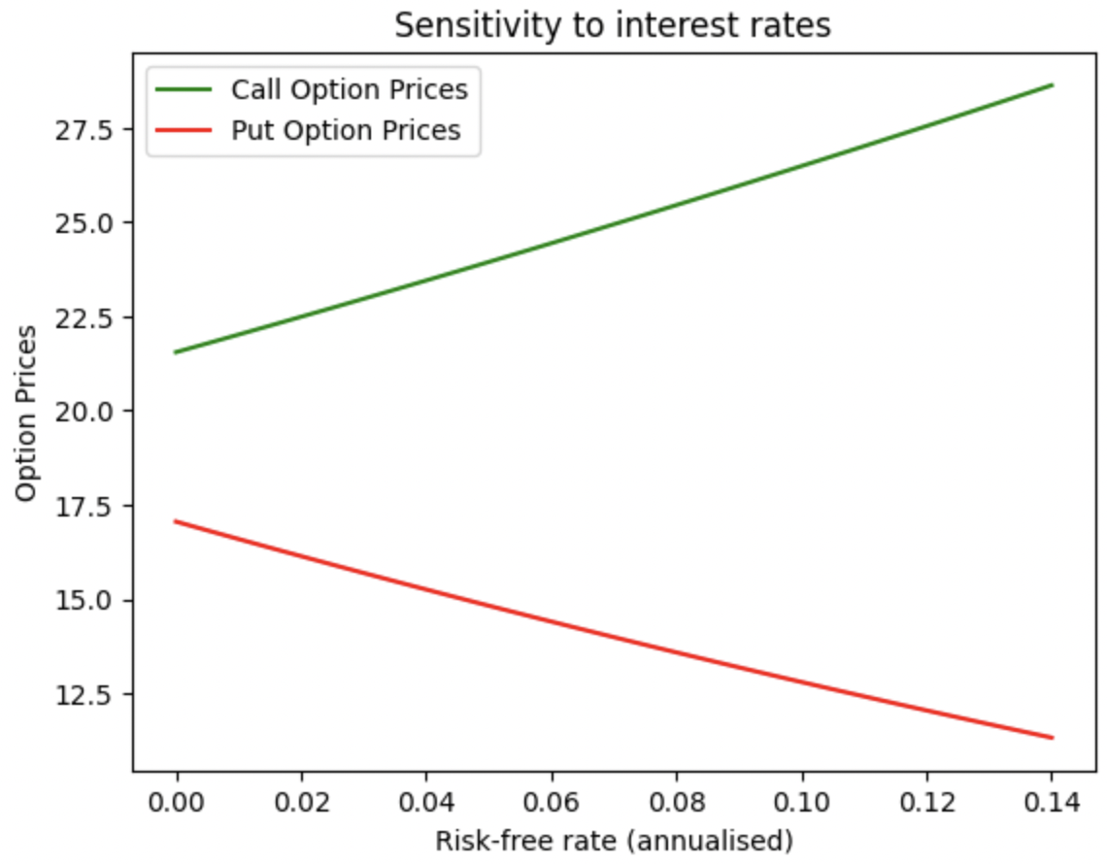

*Fig 2.4 The graph shows that call & put option prices have contrasting relations to the risk-free rate*

Call option prices have a positive relationship with the risk-free interest rates because as the interest rates rise, buying calls (as opposed to buying the underlying security) becomes more profitable and that drives the option prices higher. In the case of put options, however, the opportunity cost of buying put options (as opposed to short selling the underlying) is greater in high interest rate environments than in low interest rate environments, and this drives put prices lower with any rise in interest rate. Same can be observed in the above sensitivity plot.

**Brief on option theory and option hedging risk relation:**

Options are often used as risk management tools for hedging the portfolios. The option Greeks can be used to manage portfolio risk containing options, futures and stocks. The Greeks are referred to the quantities of sensitivities of option price due to changes in the factors that determine the value of the option. These factors include the stock price, volatility, interest rate and time to expiration.

**Delta** measures the changes in the option price to changes in the price of underlying. It is referred to as the first derivative of the option value with respect to the price of the underlying. When option risk is being monitored the delta is used as hedge ratio to have a delta neutral portfolio.

**Gamma** measure the changes in delta to changes in the price of the underlying. Gamma is the second derivative of the option value with respect to the price of the underlying.

**Vega** measures the sensitivity of option price to changes in volatility of the underlying asset. While hedging it is important to monitor Vega since both call and put options are affected with increase in volatility. Some of the option strategies benefit with increase in the volatility while others could incur huge losses in changes in volatility. For long position Vega is positive while Vega is negative for short positions. Volatility risk can be neutralised by aiming for Vega which is neither positive nor negative. The Vega is maximum when the option is at the money.

**Rho** measures the changes in the option price to changes in risk free interest. In the hedging process rho is the less utilized Greeks as the option value is less sensitive to risk free rate compared to other factors mentioned above.

**Theta** measures the changes in option price to passage of time. Option value is characterised by time value and intrinsic value. With passage of time the option loses the time value as the option nears the expiration date. Theta is always negative for long call and put positions and always positive for short positions. Theta is not generally used for hedging options.

**Objective 3- Comparison of B-S-M price and intrinsic value of the option**

An option price comprises of two components, **intrinsic value (IV)** and **time value (TV)**.

*Option Price = IV + TV*

IV is the difference between the current price of the underlying security and the strike price of the option. It’s calculated based on how the price of the underlying security moves in relation to the option strike price. On the other hand, TV is just the premium paid to hold onto the potential upside until option expiry. As the expiry time nears, TV reduces and eventually becomes zero on the expiration date, which means that option price is simply IV at expiry.

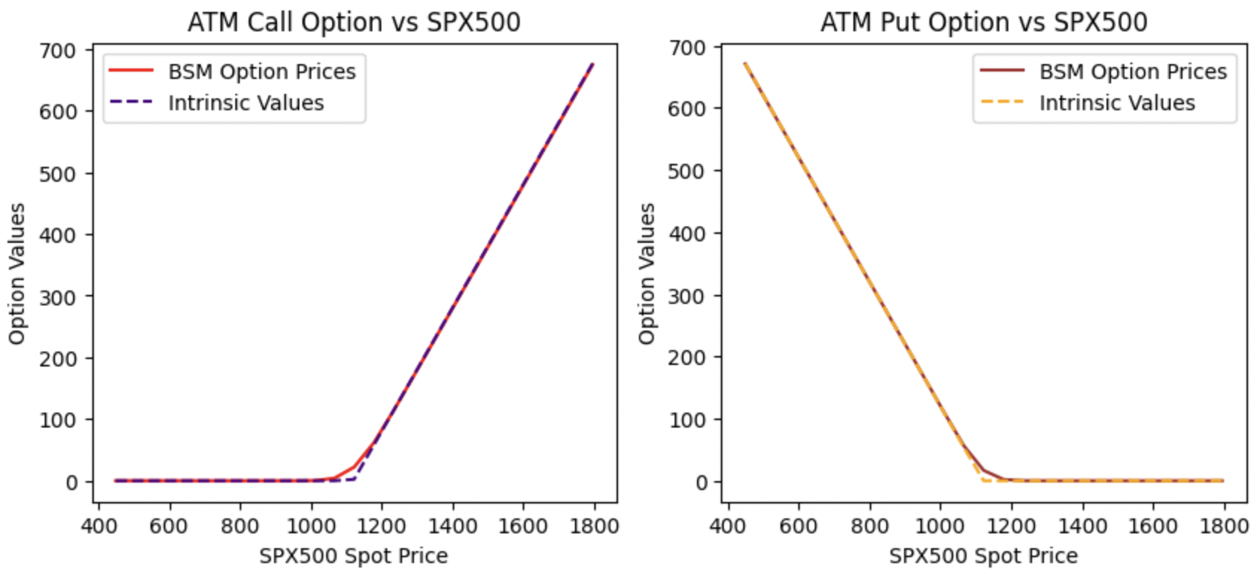

*Fig 3.1 The graph plots the B-S-M option price along with intrinsic values for call and put options*

For a call option,

*IV = Max(S – K, 0)*

For a put option,

*IV = Max(K – S, 0)*

where, K => option strike price; S => spot price of the underlying security

Using the above functions, we computed IVs for both call and put options for a range of differing spot prices. The above plot depicts the variation of IVs and B-S-M option prices (computed using the B-S-M formula) for both call & put options. We can observe that IV for the call option is zero for all spot prices below the strike ($1120.0) and increases linearly thereafter. For the put option though, IV decreases linearly with increasing spot prices (increasing spot prices make a put option less profitable) until it equals the strike ($1120.0) and becomes zero thereafter. However, we see a slight curvature for their respective B-S-M prices plot. This is because TV of an option is maximum when its strike equals the underlying spot price and gradually falls when spot prices move in either direction. For both at-the-money and out-the-money option, IV is zero and it’s often profitable for an investor to sell the option. When spot prices are greater than the strike, option will be in-the-money and will have an IV and thus the investor will be better off exercising the option in most cases.

**Objective 4- SPX volatility forecasting and comparison with implied volatility**

We calculated annualized volatility forecast along with the realized volatility of S&P 500.

Annualised volatility values (%) on our option trade date: 18/03/2004

|  |  |
| --- | --- |
| SPX Forecast Volatility | 14.50 |
| SPX Realized Volatility | 12.32 |
| VIX | 18.53 |
| ATM Call Implied volatility | 17.05 |
| ATM Put Implied volatility | 16.02 |

The realized volatility was lower than the forecasted volatility. Implied volatility of options was calculated to be higher which could be due to the fact the market takes into consideration the dynamic hedging transaction costs and gap risk.

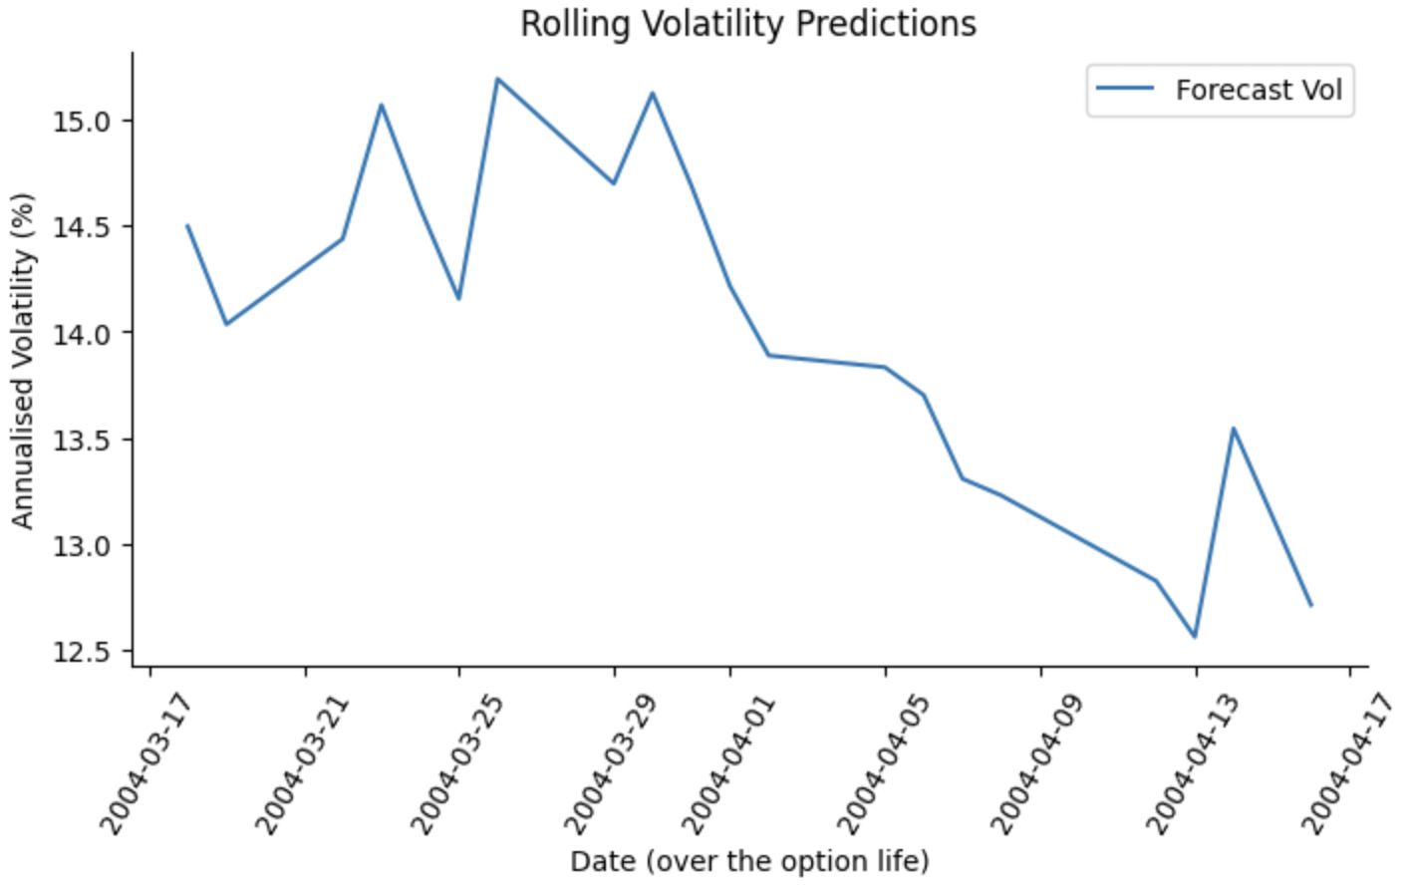

*Fig 4.1 The graph represents the forecasted volatility over the years*

We can observe from the above table that the forecasted SPX volatility ***(14.50 %)*** is lesser than the VIX value ***(18.53 %)*** on our trade date. This indicates that the general market has priced in higher volatility levels and appears to be overvalued as on the trade date. It's further supported by the higher implied volatility values observed for both of our ATM call and put options, i.e. the option prices have factored in higher volatility values, thus shooting up their premiums which leaves room for some price correction over time to expiry.

Given the scenario, we choose to construct an option spread portfolio to trade the volatility using a **Short Straddle strategy** where we short both, ATM call and ATM put options on our trade date. The rationale for this strategy is we expect Implied Vol to reduce significantly by option expiry, allowing most if not all of the premium received on the short put and short call positions to be retained. Volatility trading refers to the trading strategies that provide an exposure to implied and realized volatilities of underlying asset.

**Short straddle strategy**

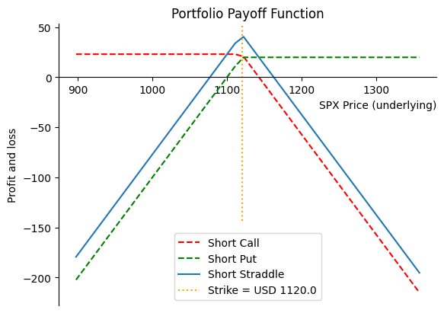

*Fig 4.2 The graph represents the payoffs for short straddle strategy*

**Maximum Profit:**

Overall portfolio profit potential is limited to the total premiums ***($ 42.7)*** received less any transaction costs (transactions not factored in the above plot). The maximum profit is earned if the short straddle is held to expiration and the index price closes exactly at the strike price ***($ 1120.00),*** i.e. both the options expire worthless.

**Maximum Loss:**

As we can infer from the above plot, potential loss is unlimited on the upside because the index price can rise indefinitely. There's a substantial downside risk too since the index prices can crash significantly from current levels to reach an absolute zero (highly unlikely for an index).

There are 2 potential breakeven points:

1. Strike price plus total premium => 1120.0 + 42.7 = $ 1162.7
2. Strike price minus total premium => 1120.0 - 42.7 = $ 1077.3

So, if the index price on expiry date is within these bounds, then our portfolio will have a positive return and moneyness property of ITM



We created a portfolio of a put & a call option. Since we sold both these options, there was no initial buy cost associated with it. Following on with the **Short Straddle Strategy**, we were able to make a profit of **$ 8.30** on expiry date with the above mentioned portfolio composition.

**Objective 5 - Under the assumption of short ATM call option the delta hedging was implemented.**

**a)** Delta hedging values from B-S-M assuming **Implied Volatility of 17.05%:**

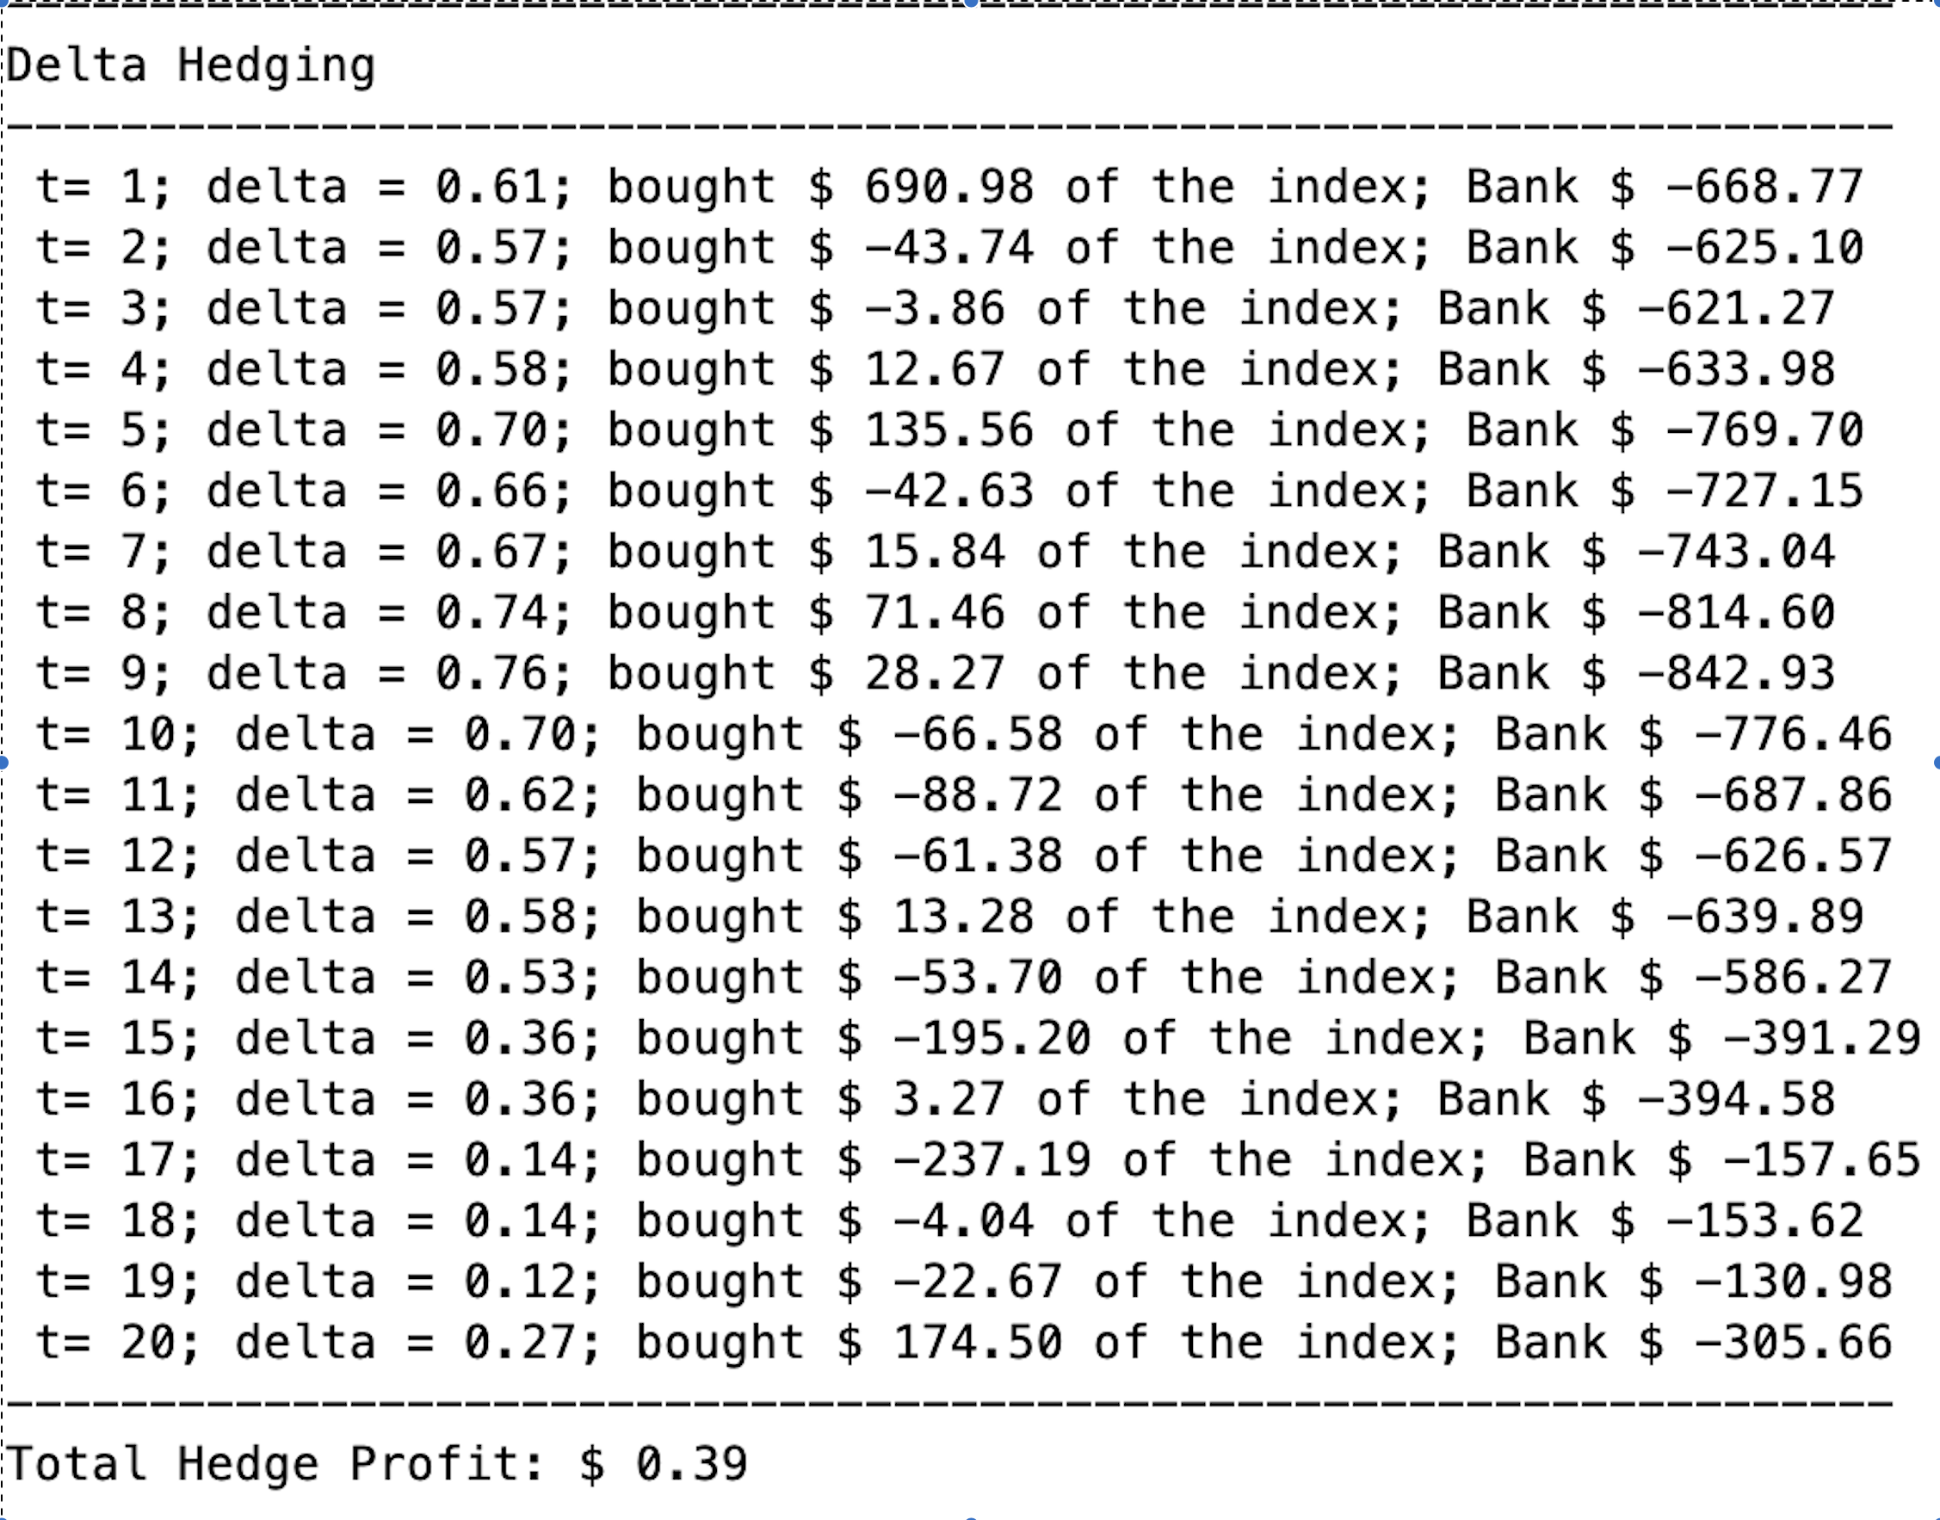

*Table 5.1 The table represents the daily delta hedged call positions*

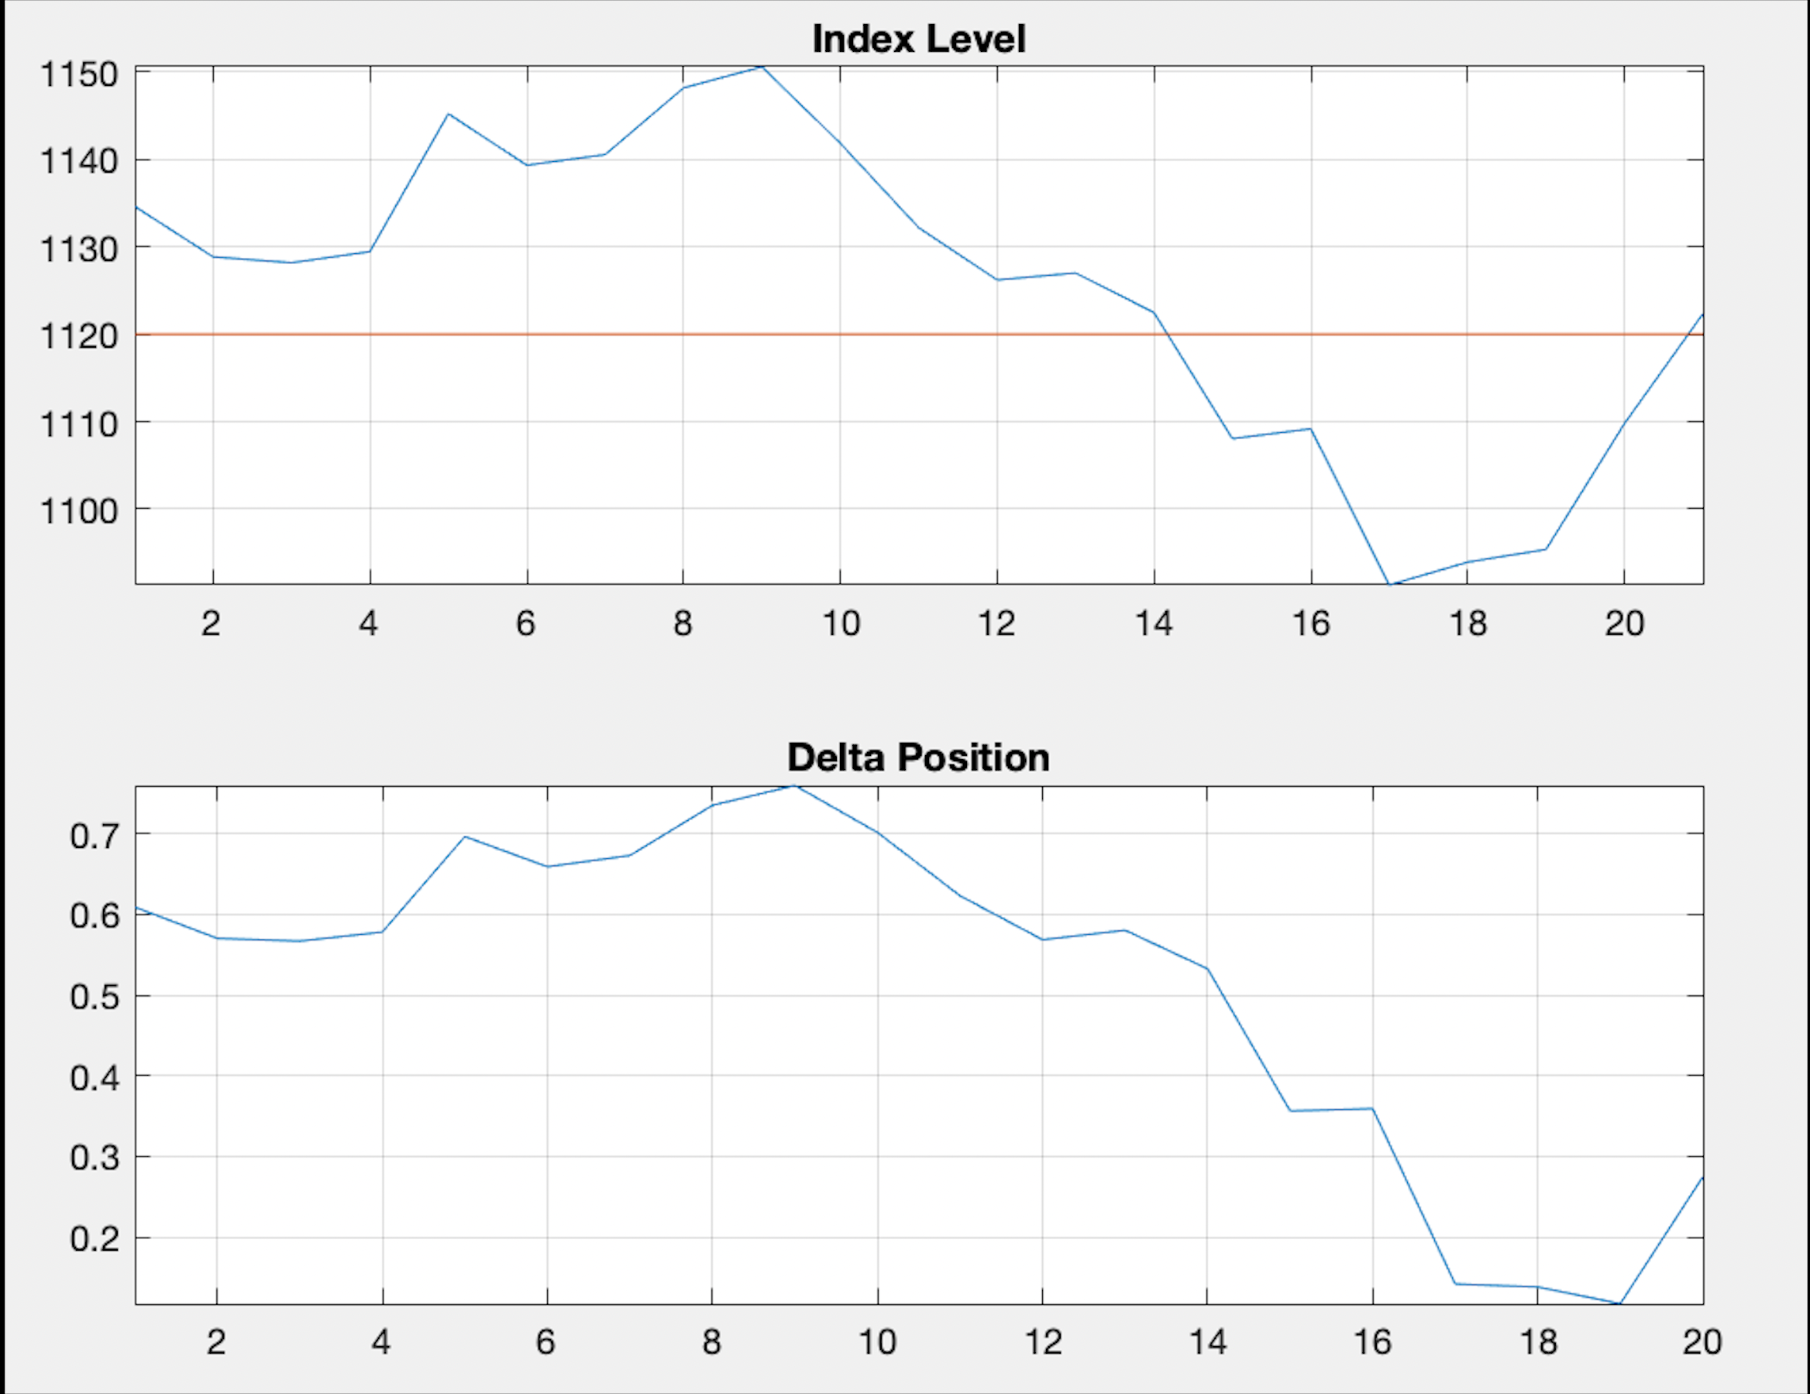

*Fig 5.1 The graph represents the plots of daily delta values until expiration with implied volatility*

The hedge profit using Implied volatility is **$ 0.39**

**b)** Delta hedging values from B-S-M assuming **Volatility Forecast of 14.50%:**

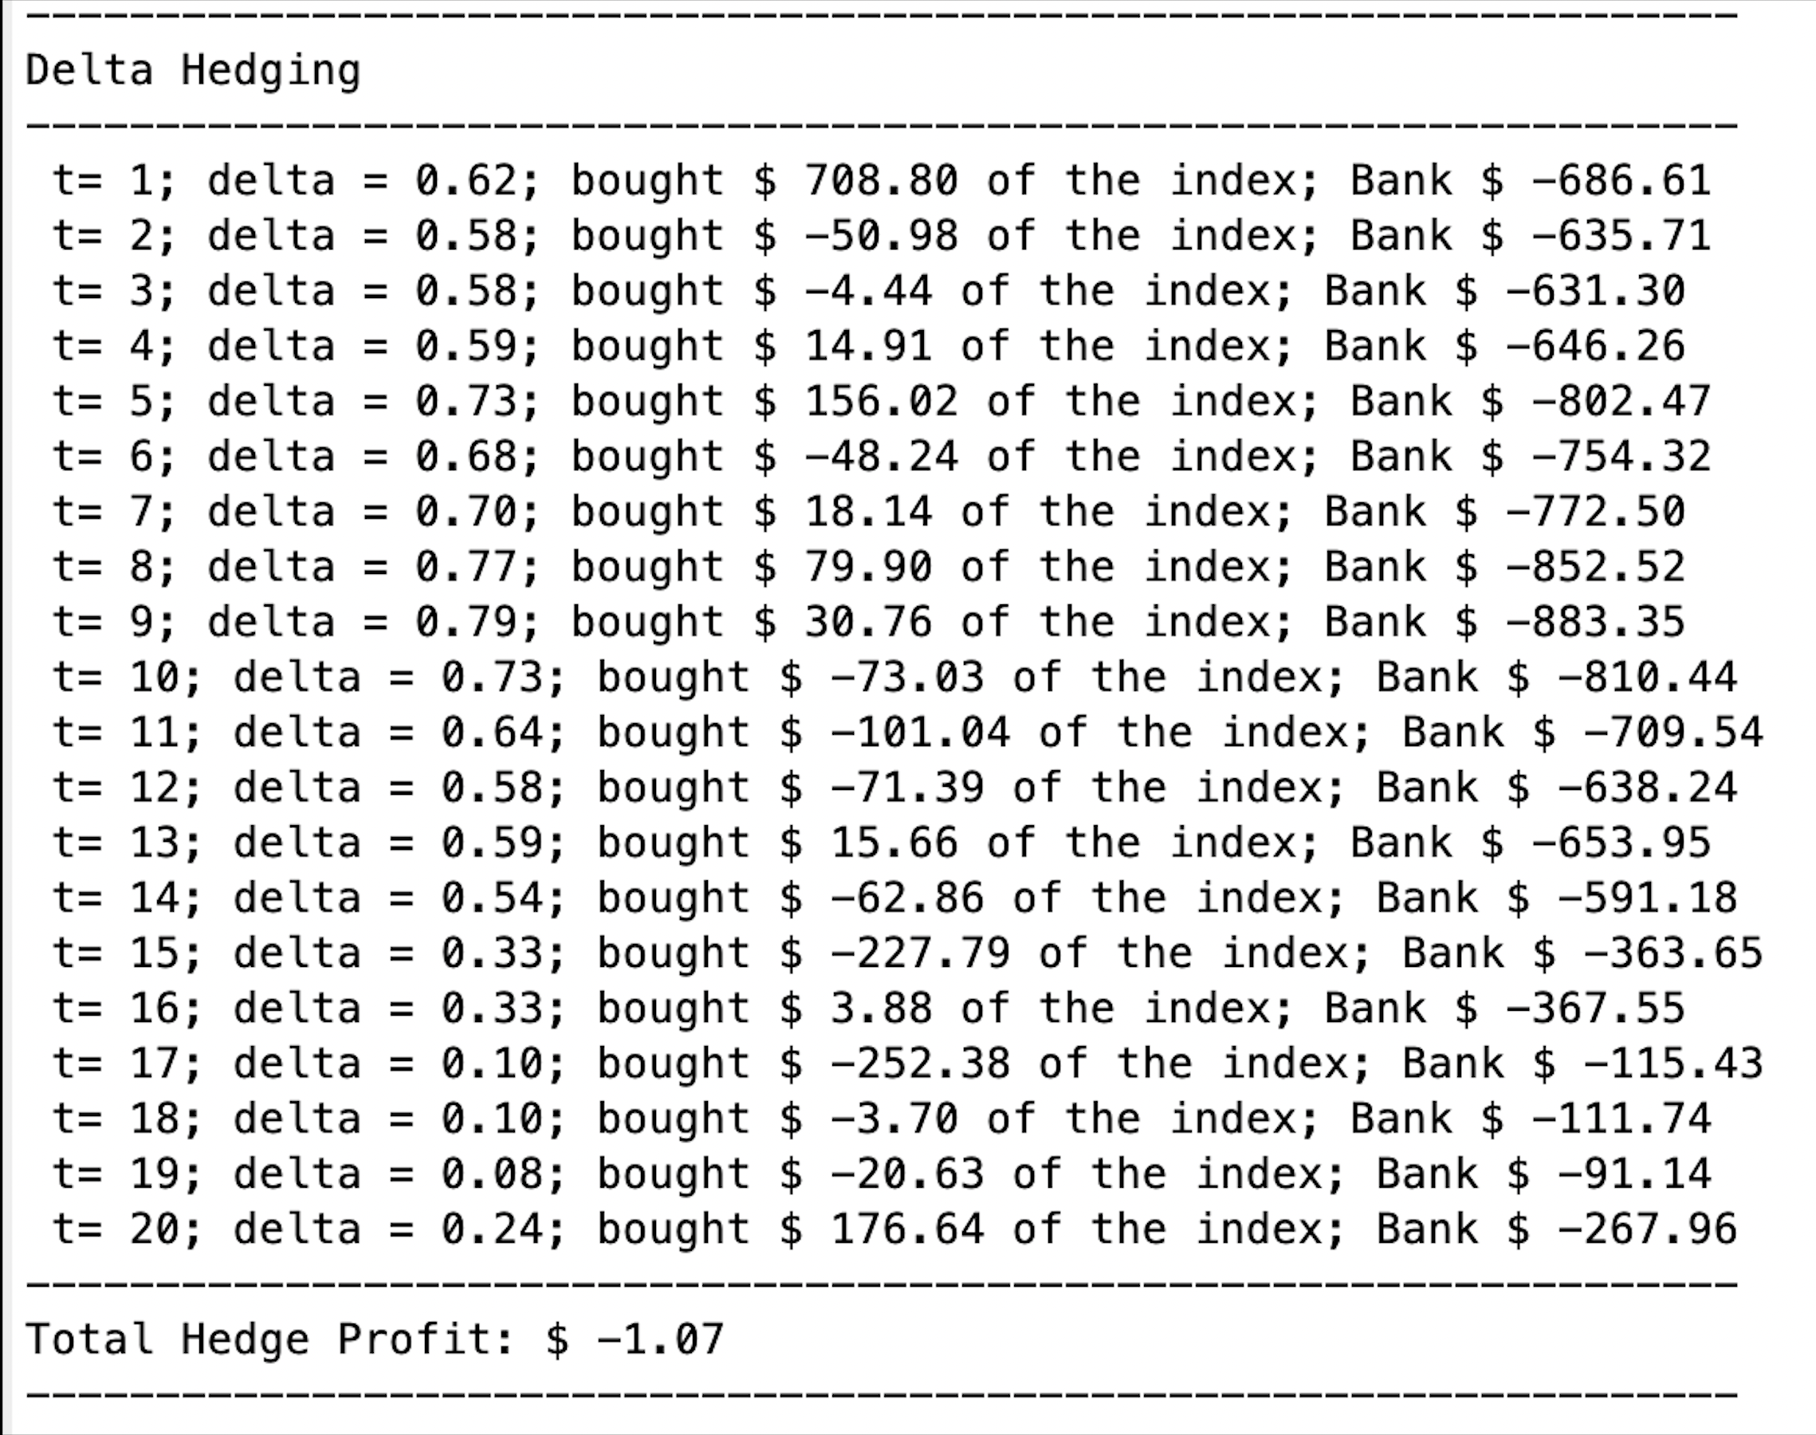

*Table 5.2 The table represents the daily delta hedged call positions*

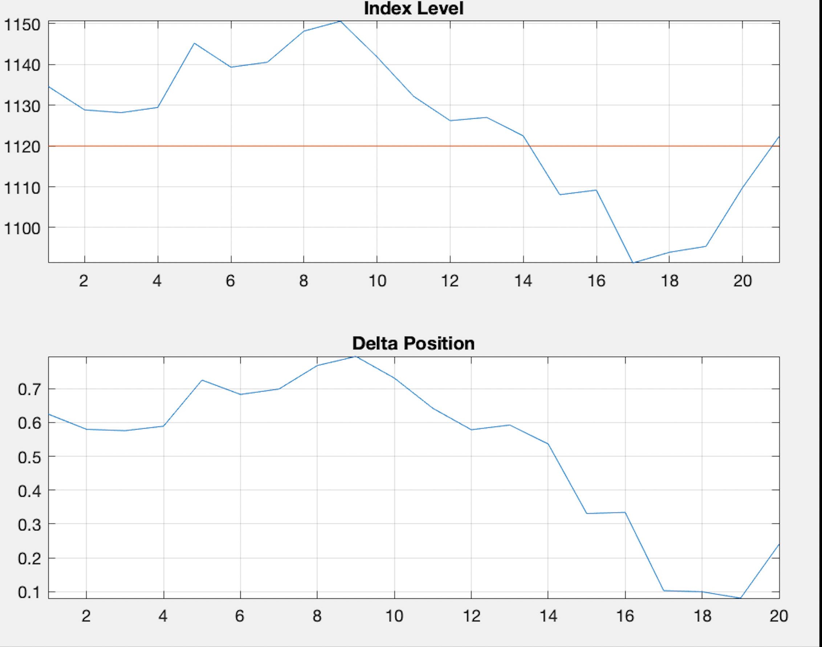

*Fig 5.2 The graph represents the plots of daily delta values until expiration with forecasted volatility*

The hedge profit using Volatility forecast is ***$ -1.07***

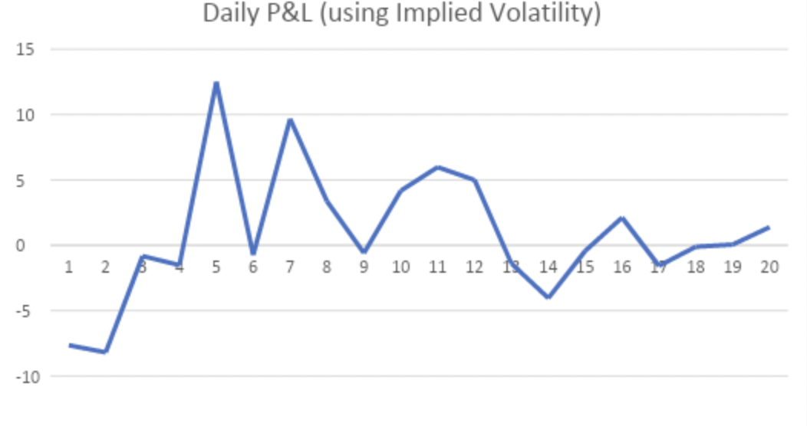

*Fig 5.3 The graph represents the daily P&L using implied volatility*

A writer of a call option undertakes delta hedging since the trader is exposed to losses if the underlying stock price increases above the strike price at expiry. In the above delta hedging exercise the end of the period P&L resulted in a profit of ***$ 0.39*** using the higher implied volatility and a loss ***of $ 1.07*** when lower volatility forecast was used. The difference in the P&L results could be attributed to the difference in the implied volatility and forecasted volatility.

**Group 6 (individual member contributions):**

|  |  |
| --- | --- |
| **Names** | **Contributions** |
| Kuntoji, Rohan | * Led the project management by assigning individual tasks & organising regular team meet-ups * Problem solving using Python tool & inferencing results |
| Nagar, Shraddha | * Research on BSM option pricing topics * Problem solving using MATLAB tool |
| Fernandes, William | * Research on delta hedging * Inferences and report writing |
| Pant, Vidushi | * Research on sensitivity analysis * Inferences and report writing |
| Parary, Aman | * Research on option spread & strategy * Problem solving using Python tool |